NAME:NAVODITAA
ROLL NO.:241901071

Exercise 14

LEARNING AND ASSIGNMENT OF IP ADDRESS MANUALLY TO COMPUTERS
Aim:
To manually assign IPv4 addresses, subnet mask, and default gateway to computers in a network and verify connectivity between hosts.
Introduction:
In computer networks, every device requires a unique IP address to communicate. Manual IP assignment (static IP) is when the IP address, subnet mask are set manually instead of using DHCP. This experiment helps understand addressing, subnetting, and basic connectivity verification using ping.
Algorithm:
- Prepare network devices:
- Place 2 PCs and 1 switch (and router if using a gateway) in Packet Tracer.
- Connect devices:
- Use Copper Straight-Through cable:
- PC → Switch
- Switch → Router (optional)
- Assign IP addresses:
IP Address: 192.168.1.1
Subnet Mask: 255.255.255.0
IP Address: 192.168.1.2
Subnet Mask: 255.255.255.0
- Verify connectivity:
- On PC0 → Command Prompt → ping 192.168.1.2
- On PC1 → Command Prompt → ping 192.168.1.1

Output:

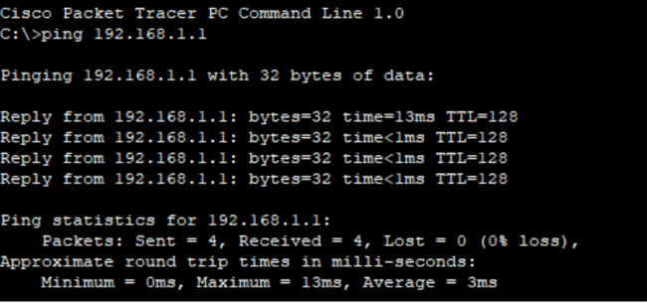

Result:
Manual IP addresses were successfully assigned to the PCs.

